**INFOLABZ IT SERVICES PVT. LTD.**

**Course :** React

**Session No :**

**Topics to be covered :** Map in react, Map with react bootstrap, Object data

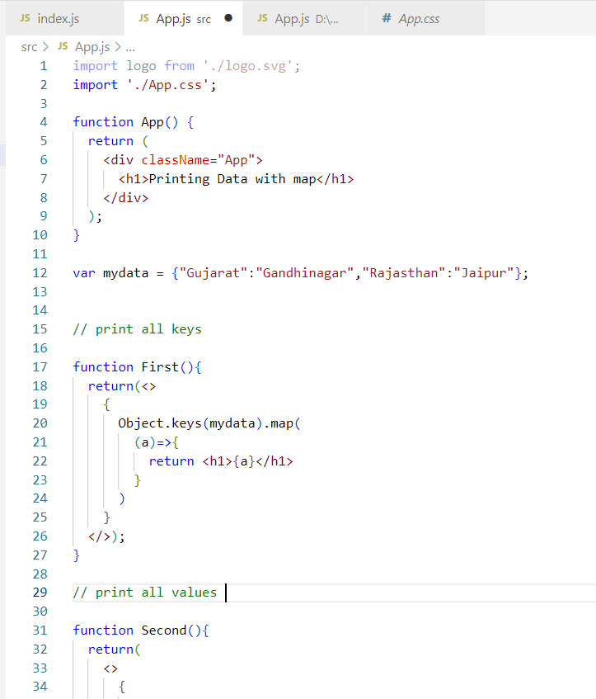

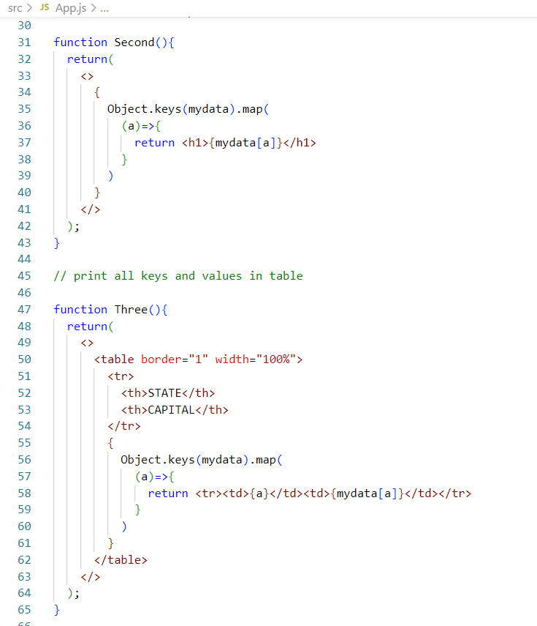

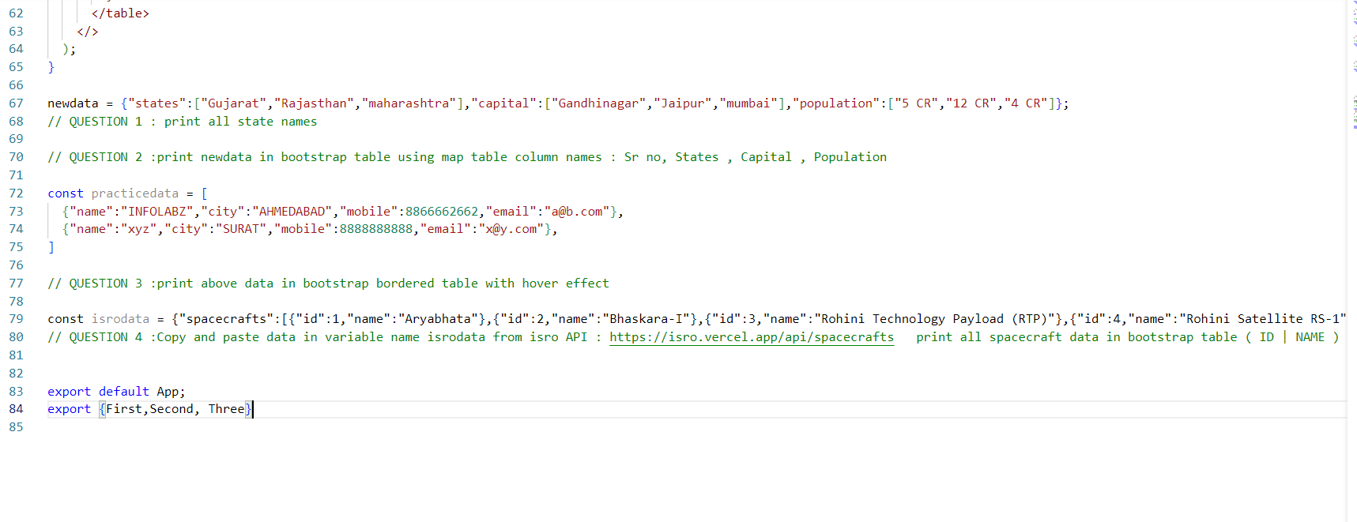

newdata = {"states":["Gujarat","Rajasthan","maharashtra"],"capital":["Gandhinagar","Jaipur","mumbai"],"population":["5 CR","12 CR","4 CR"]};

// QUESTION 1 : print all state names

// QUESTION 2 :print newdata in bootstrap table using map table column names : Sr no, States , Capital , Population

const practicedata = [

{"name":"INFOLABZ","city":"AHMEDABAD","mobile":8866662662,"email":"a@b.com"},

{"name":"xyz","city":"SURAT","mobile":8888888888,"email":"x@y.com"},

]

// QUESTION 3 :print above data in bootstrap bordered table with hover effect

const isrodata = datafromapi;

// QUESTION 4 :Copy and paste data in variable name isrodata from isro API : https://isro.vercel.app/api/spacecrafts print all spacecraft data in bootstrap table ( ID | NAME )

PRINTING LIST DATA WITH REACT MAP

